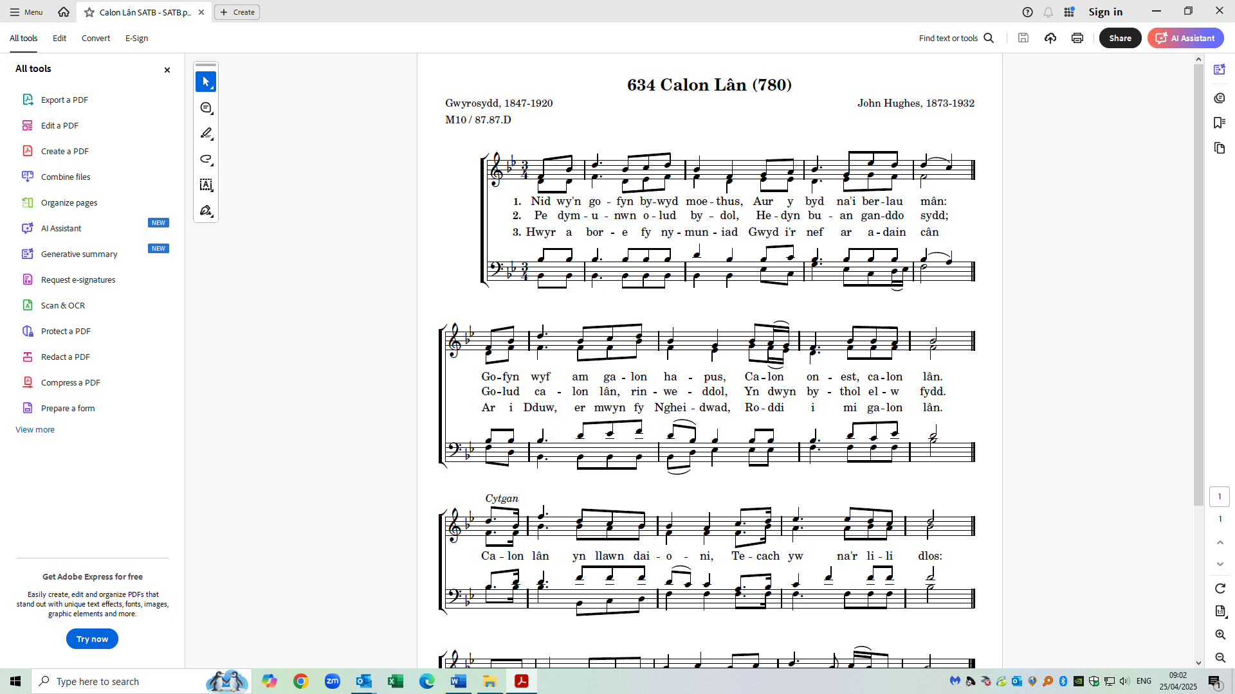

1. Need oo-een goh – vin bo – wid moy - this, Ai-er uh beed nye bear-lie maan:

2. Pe dum - in – oon o - lid bu - dol , Hed– in bee - an gan-though seethe;

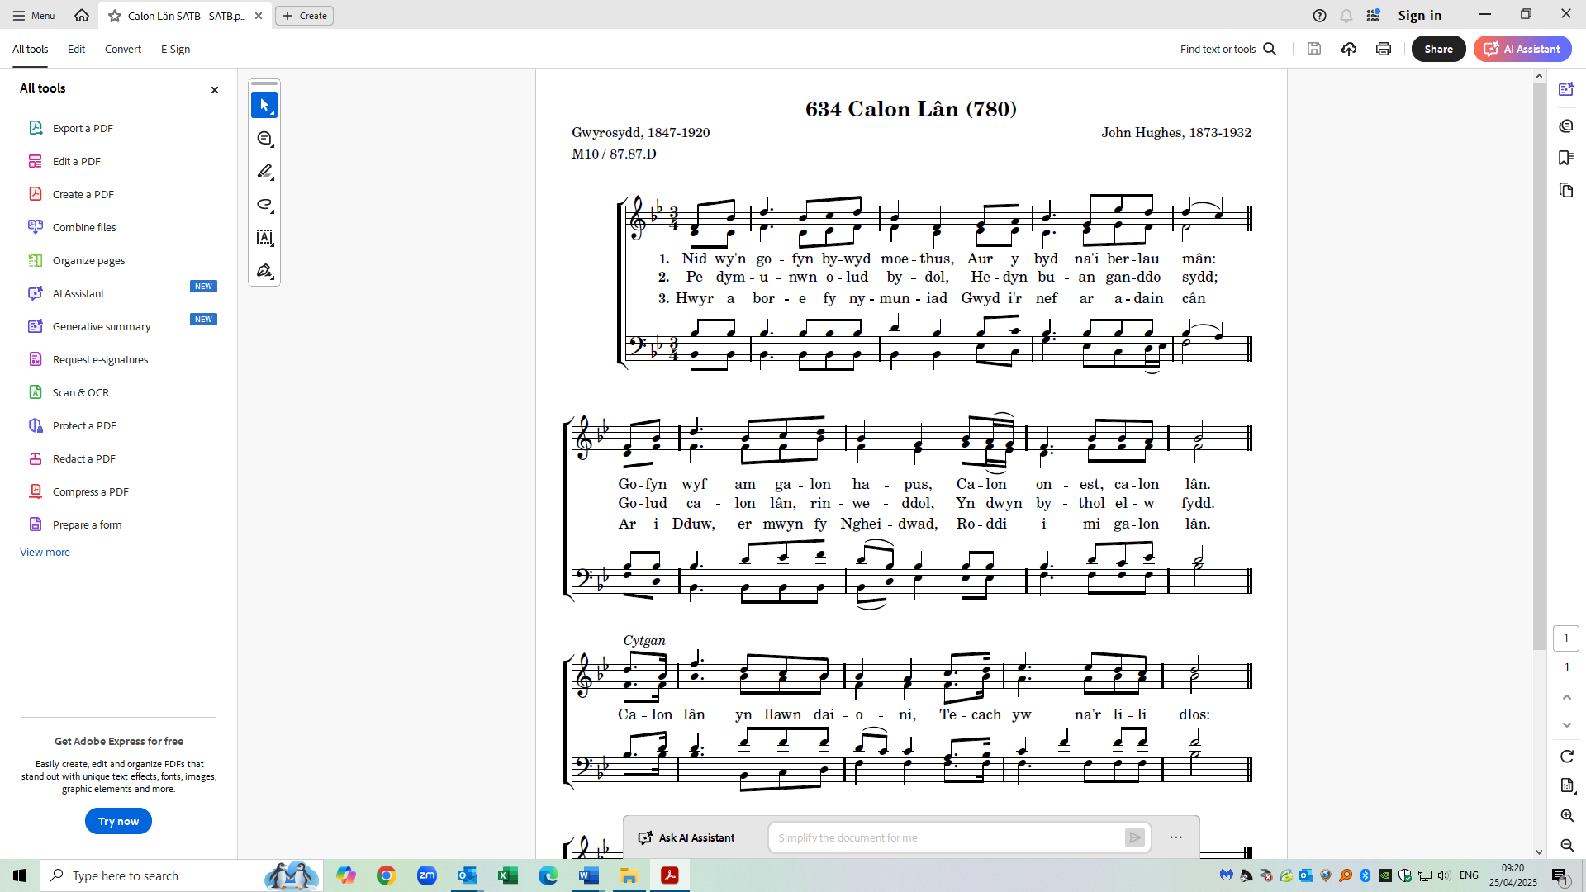 3. Who-ee-r uh bo - ray vuh num - in - yad, Gooid ir nave ar ah - dine kaan

Goh-vin oi-v am gah – lon hap - pis, Ka - lon on - nest, ka – lon laan.

Go - lid Ka - lon laan rin weth - ol, Un do-in’ buth - ol ell - oo veeth.

Ahr ee Ddewe, er moo–in vung hayd - wad, Ro - thee ee - mee gah -lon laan .

Ka - lon laan un llown da - yon - ee, Tek – ach yoo naar li - ly dlos:

Dim ond ka - lon laan ahll gaa - ny . Kah – nee’r deeth ah cha - nee’r norse.